Obzory matematiky, fyziky a informatiky 4/2008 (37)
Štýl 0MFI - Nadpis článku

The Paradox of the Flying Rod
Štýl 0MFI - Abstract - anglický
Štýl 0MFI – Meno autora
Aba Teleki
Abstract: The aim of this article is to show a simple geometrical method applicable in solving some kind of two (and more) dimensional relativistic problems. The method is demonstrated on a well known paradox of flying rod.
Key words: theory of relativity, paradox, Lorentz transformation
Štýl 0MFI – Key words
Súhrn: Cieľom práce bolo ukázať jednoduchú geometrickú metódu k riešeniu niektorých dvoj- a viacrozmerných úloh v špeciálnej teórii relativity. Metóda je demonštrovaná na dobre známom paradoxe letiacej tyče.
Štýl 0MFI – Kľúčové slová
Štýl 0MFI - Abstrakt- slovenský
Kľúčové slová: teória relativity, paradox, Lorentzova transformácia
Štýl 0MFI – MESC kódy
MESC: M50

Introduction
Štýl 0MFI – Nadpis úrovne 1
There is many interesting paradoxes in special theory of relativity and many methods how to solve them. The universal method is based on the Lorentz transformation (only the first paragraph in the section is without indent)
Equations place in the second column. The table has three columns (width: 1 cm, 11, cm, 1 cm). Creae the equations by using the Equation editor.
Štýl 0MFI – Základný text – 1. odstavec
Štýl 0MFI – Základný text za vzorcom  Štýl 0MFI - Vzorec | $cΔt_{2}=γcΔt_{1}+βγΔx_{1}$,  $Δx_{2}=βγcΔt_{1}+γΔx_{1}$,  $Δy_{2}=Δy_{1}$,  $$Δz_{2}=Δz_{1},$$ | (1a)  (1b)  (1c)  (1d)
where
 | $β=\frac{v}{c}$ and $γ=\frac{1}{\sqrt{1-β^{2}}}$. | (2)
…
One cannot use directly the very effective geometric method of Loedel’s diagrams presented in [1-6], for more dimensional problems. The using of Lorentz transforms (1) by combining boosts in two different directions may cause significant problems. The essence of the problem is hidden in the properties of parallelism in the special theory of relativity. (the second and other paragraphs in the section are with indent)
Štýl 0MFI – Základný text
…

Observing from the frame of the wall
Look figure 2 describing the general situation from the point of view of the observer 1. Anything in this paragraph is described from the point of view of the observer 1, i.e. in the frame $S_{1}.$ (use the Equation editor to create a mathematical symbol in the text )
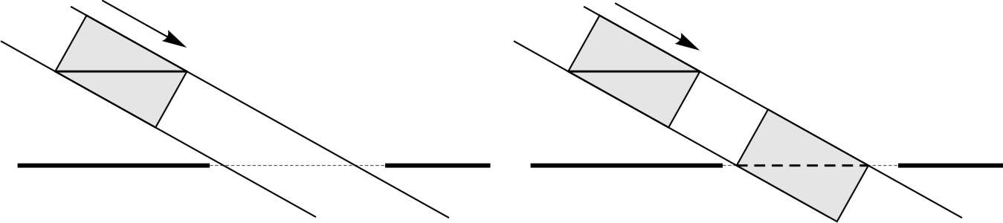
Štýl 0MFI – Obrázok popis
Štýl 0MFI – Obrázok na celú šísku
Fig. 2: a) The rod flying with velocity $v=0,866c$ toward the wall encompassed by the R-box. In the frame $S_{1}$ the flying rod is paralell by the wall all the time. b) The H-box and R-box are identical in the frame $S_{1}$. While the R-box is flying with the velocity $v$ in the frame $S_{1}$, the H-box is in rest.
R-box
$$v$$
H-box
R-box
$$v$$
$$S_{1}$$
$$S_{1}$$
…

Conclusion
By using the linearity of the Lorentz transformations, and the relativistic length contraction formulae, one can solve two (or three) dimensional problems without any difficulties. It is not necessary to be familiar with the complicated algebra of the Lorentz group SO(3,1).

Acknowledgement
The article was supported by the Ministry of Education of the Slovak Republic under Grants no. KEGA 3/6472/08.

References
Štýl 0MFI – Literatúra – nadpis
[1] Albert Shadowitz, Special relativity, Dover Publications, Inc. Mineola, 1988,
ISBN: 978-0486657431
Štýl 0MFI – Literatúra – položky
[2] Boris Lacsný. Špeciálna teória relativity pomocou Loedelovych diagramov 1. (The Special Theory of Relativity by using Loedl’s Diagrams 1.), OMFI, 35(1):32–36, 2006.
[3] B. Lacsný. Špeciálna teória relativity pomocou loedelových diagramov 2. (The Special Theory of Relativity by using Loedl’s Diagrams 2.), OMFI, 35(2):30–35, 2006.
[4] B. Lacsný. Špeciálna teória relativity pomocou loedelových diagramov 3. (The Special Theory of Relativity by using Loedl’s Diagrams 3.) OMFI, 35(3):25–31, 2006.
[5] B. Lacsný. Relativistické sčítanie rýchlosti v Loedelovych diagramoch. (Relativistic Addition Rules for Velocities in Loedel’s Diagrams) In CoPhys International Physics Workshop 2006 (for Departments of Physics of European Universities Collaborating in Science), edited by Teleki A. Kluvanec D. Medved’ I.,volume 1, Nitra, 2007. pp. 33-37,
ISBN 978-80-8094-084-3
[6] Boris Lacsný, Aba Teleki, Progresívna metóda budovania znalostí základov špeciálnej teórie relativity – Loedelove diagram (Methods of Progressive Build-up of Basic Knowledgs in Special Theory of Relativity – The Loedel’s Diagrams), Edícia Prírodovedec č. 310, FPV UKF v Nitre, pp. 1-135, ISBN 978-80-8094-343-1
Author Address: RNDr. Aba Teleki, PhD., Department of Physics, Faculty of Natural Sciences, Constantine the Philosopher University in Nitra, Tr. A. Hlinku 1, SK-949 74 Nitra, Slovakia, e-mail: ateleki@ukf.sk
Štýl 0MFI – hypertextový odkaz
Štýl 0MFI – Adresa autorov

